Michael Amoo
09/25/26
CSC 395 02
AgenticCoding WeatherApp
Chutima Boonthum-Denecke

1. Project Overview
I used an Agentic Coding conversation to build a SwiftUI weather app from an empty Xcode project. The app accepts a city from the user, looks up live weather data with Open-Meteo, and displays the current conditions. I then revised the app three times through follow-up prompts instead of manually rebuilding the features myself.
Final features. The finished app includes city search, current weather, readable condition names, SF Symbol weather icons, Celsius/Fahrenheit switching, dynamic weather backgrounds, and a seven-day forecast with daily high and low temperatures.
- Agentic coding workflow: prompt, run, test, revise, and test again.
- API/data: Open-Meteo geocoding and weather forecast data.
- Swift concepts used: SwiftUI, async/await, model/service/view-model separation, Measurement<UnitTemperature>, SF Symbols, gradients, and ScrollView.
- Testing: I tested multiple locations and both temperature units after the revisions.

2. Initial Prompt and First Result

Initial Prompt
Create a simple SwiftUI weather app for iOS. The user should be able to enter a city name and tap a button to get the current weather. Use the Open-Meteo geocoding API to convert the city into latitude and longitude, then use the Open-Meteo forecast API to retrieve the current temperature and weather condition. Keep the interface simple for now. Use Swift concurrency with async/await and URLSession. Organize the code so it is easy to revise later. Do not add weather icons, dynamic backgrounds, or a multi-day forecast yet.

Result. The agent turned the empty SwiftUI project into a working weather app and separated the code into Models, Services, ViewModels, and the SwiftUI view. The first version accepted a city name and returned a location, temperature, condition, and update time. Hampton, Virginia returned 18°C and Overcast during my test.
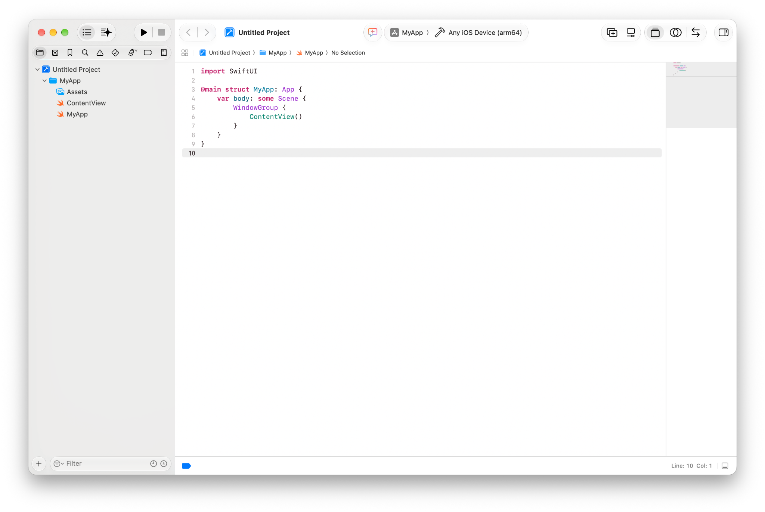
Figure 1. Empty Xcode project before the initial agentic coding prompt.
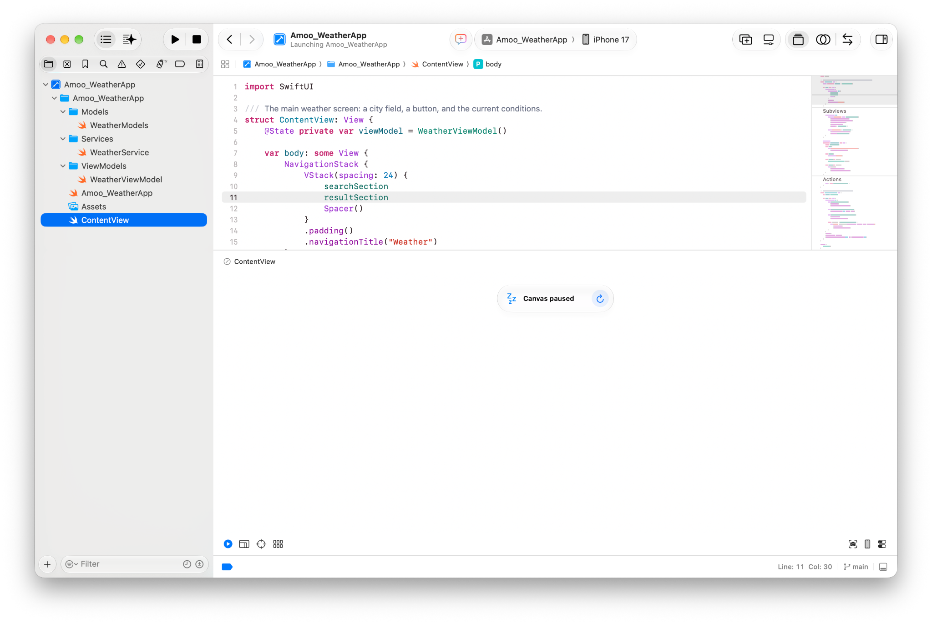
Figure 2. Project structure generated after the initial prompt.
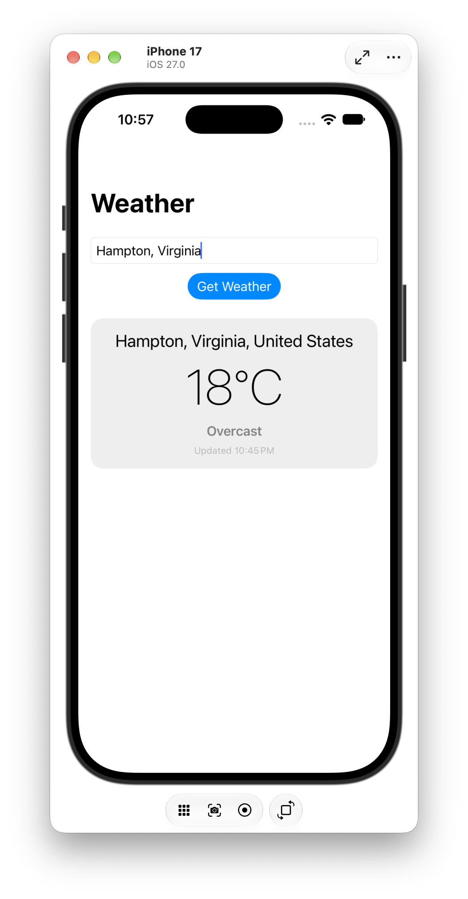
Figure 3. Initial working weather lookup for Hampton, Virginia.

Initial Code I Had Not Used Before
One of the main new ideas for me was separating the network work into a service instead of putting all of the API code inside ContentView. The service uses asynchronous functions so the UI can wait for internet results without freezing.
protocol WeatherService: Sendable {
func geocode(city: String) async throws -> Location
func currentWeather(latitude: Double, longitude: Double) async throws -> CurrentWeather
}

I also saw the app hold a view model as SwiftUI state. This keeps the screen focused on displaying data while the view model handles the loading state and weather lookup.
@State private var viewModel = WeatherViewModel()
NavigationStack {
VStack(spacing: 24) {
searchSection
resultSection
Spacer()
}
}

Observation. The first prompt already produced more structure than I would have written for a small class app. That made later revisions easier because the agent could update the model, service, and view separately.

3. Revision 1 - Weather Icon and Temperature Units

Revised Prompt 1
Revise the existing weather app to add an appropriate weather icon for the current condition. Use SF Symbols where possible and map the weather code returned by Open-Meteo to both an icon and a readable condition name. Display the icon prominently with the current temperature and condition. Keep the existing city search, Open-Meteo networking, and current weather behavior unchanged. Do not add a dynamic background or multi-day forecast yet.

Result. The agent added weather-code-to-SF-Symbol mapping and made the condition more visual. It also added a Celsius/Fahrenheit toggle, which was an extra feature beyond what I specifically requested. Tapping the temperature changed the same Hampton result from 18°C to 64°F.
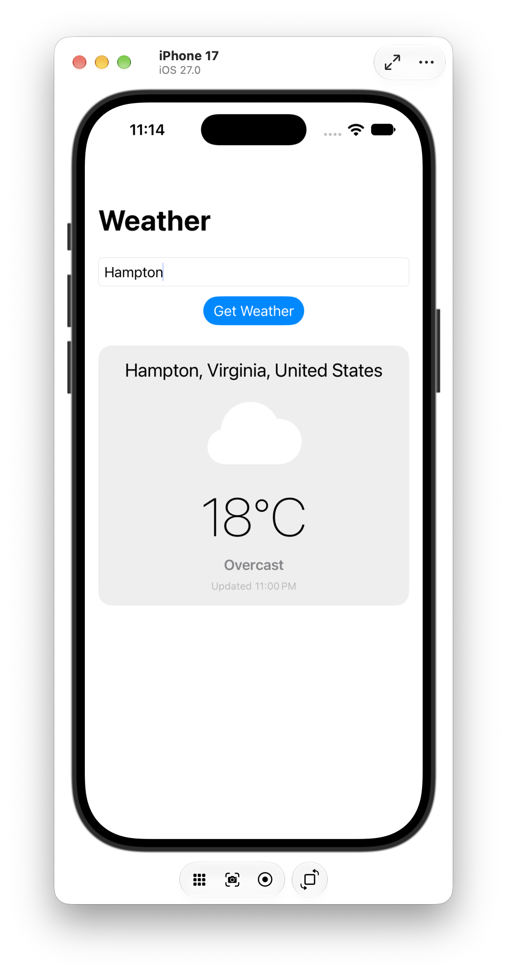 | 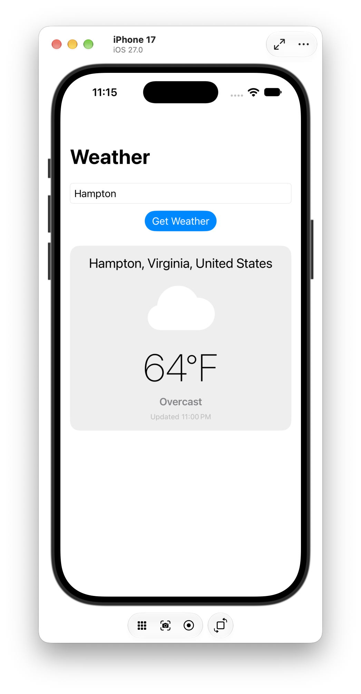
Figure 4. Revision 1 in Celsius. | Figure 5. The same weather result after switching to Fahrenheit.

Revision 1 Code Sample
The generated model uses Foundation measurement types for unit conversion instead of manually writing the Celsius-to-Fahrenheit formula. It also maps Open-Meteo weather codes to SF Symbol names.
enum TemperatureUnit: Equatable, Sendable {
case celsius
case fahrenheit
var toggled: TemperatureUnit {
switch self {
case .celsius: .fahrenheit
case .fahrenheit: .celsius
}
}
}

var symbolName: String {
switch rawValue {
case 0, 1: "sun.max.fill"
case 2: "cloud.sun.fill"
case 3: "cloud.fill"
case 61, 63: "cloud.rain.fill"
default: "questionmark.circle"
}
}

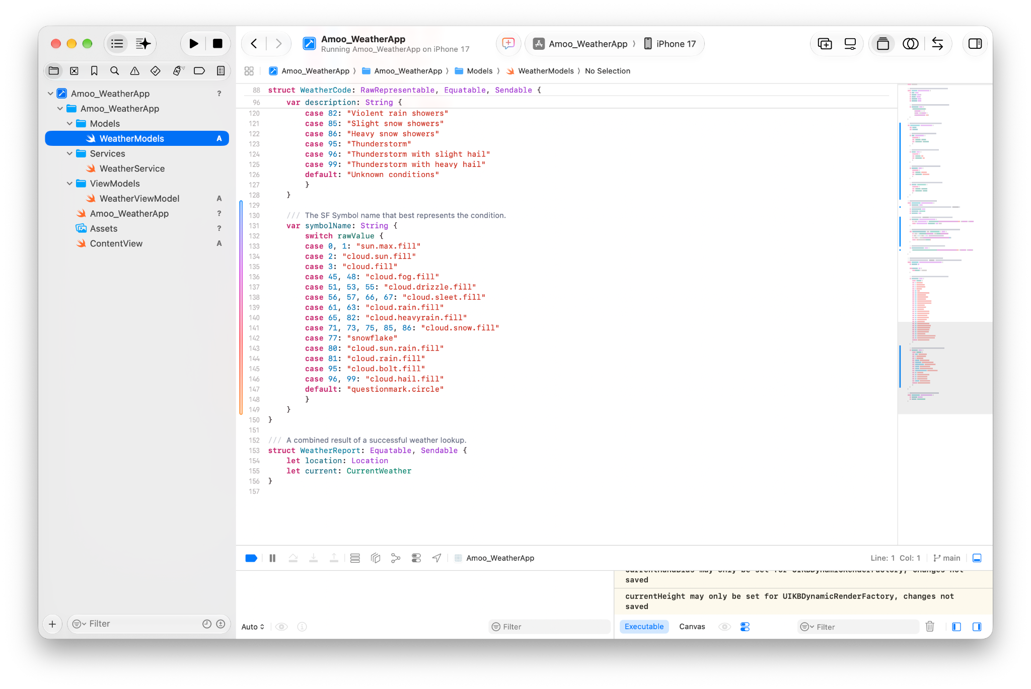
Figure 6. Agent-generated weather-code to SF Symbol mapping in WeatherModels.swift.

4. Revision 2 - Dynamic Weather Backgrounds

Revised Prompt 2
Revise the existing weather app to add a dynamic background that changes based on the current weather condition returned by Open-Meteo. Use SwiftUI gradients or colors appropriate for conditions such as clear, cloudy, rain, snow, fog, and thunderstorms. Make sure all text, the city search field, buttons, weather icon, temperature, condition, updated time, and Celsius/Fahrenheit toggle remain readable against each background. Preserve all existing functionality. Do not add a multi-day forecast yet.

Result. The agent created a WeatherCondition category and a reusable WeatherBackgroundView. The background now changes after a successful lookup. I tested more than one location to make sure the change was actually driven by the weather data instead of being a single fixed background.
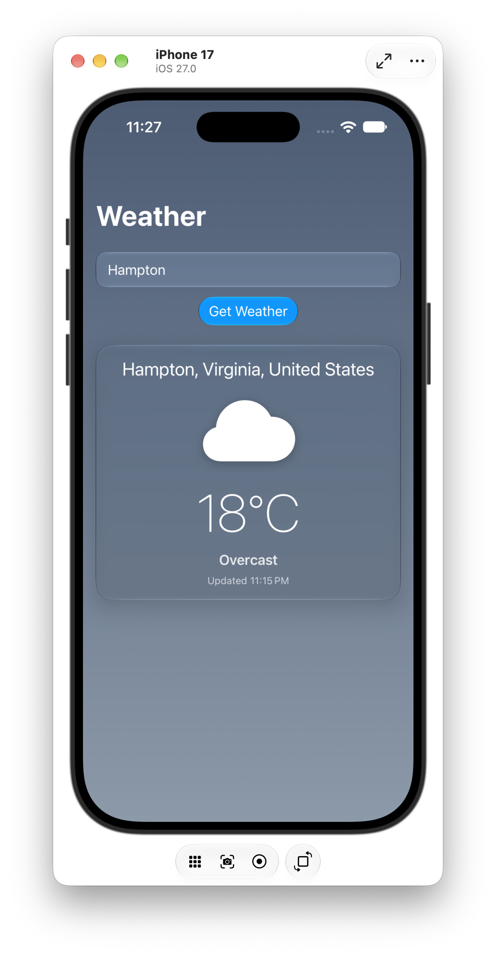 | 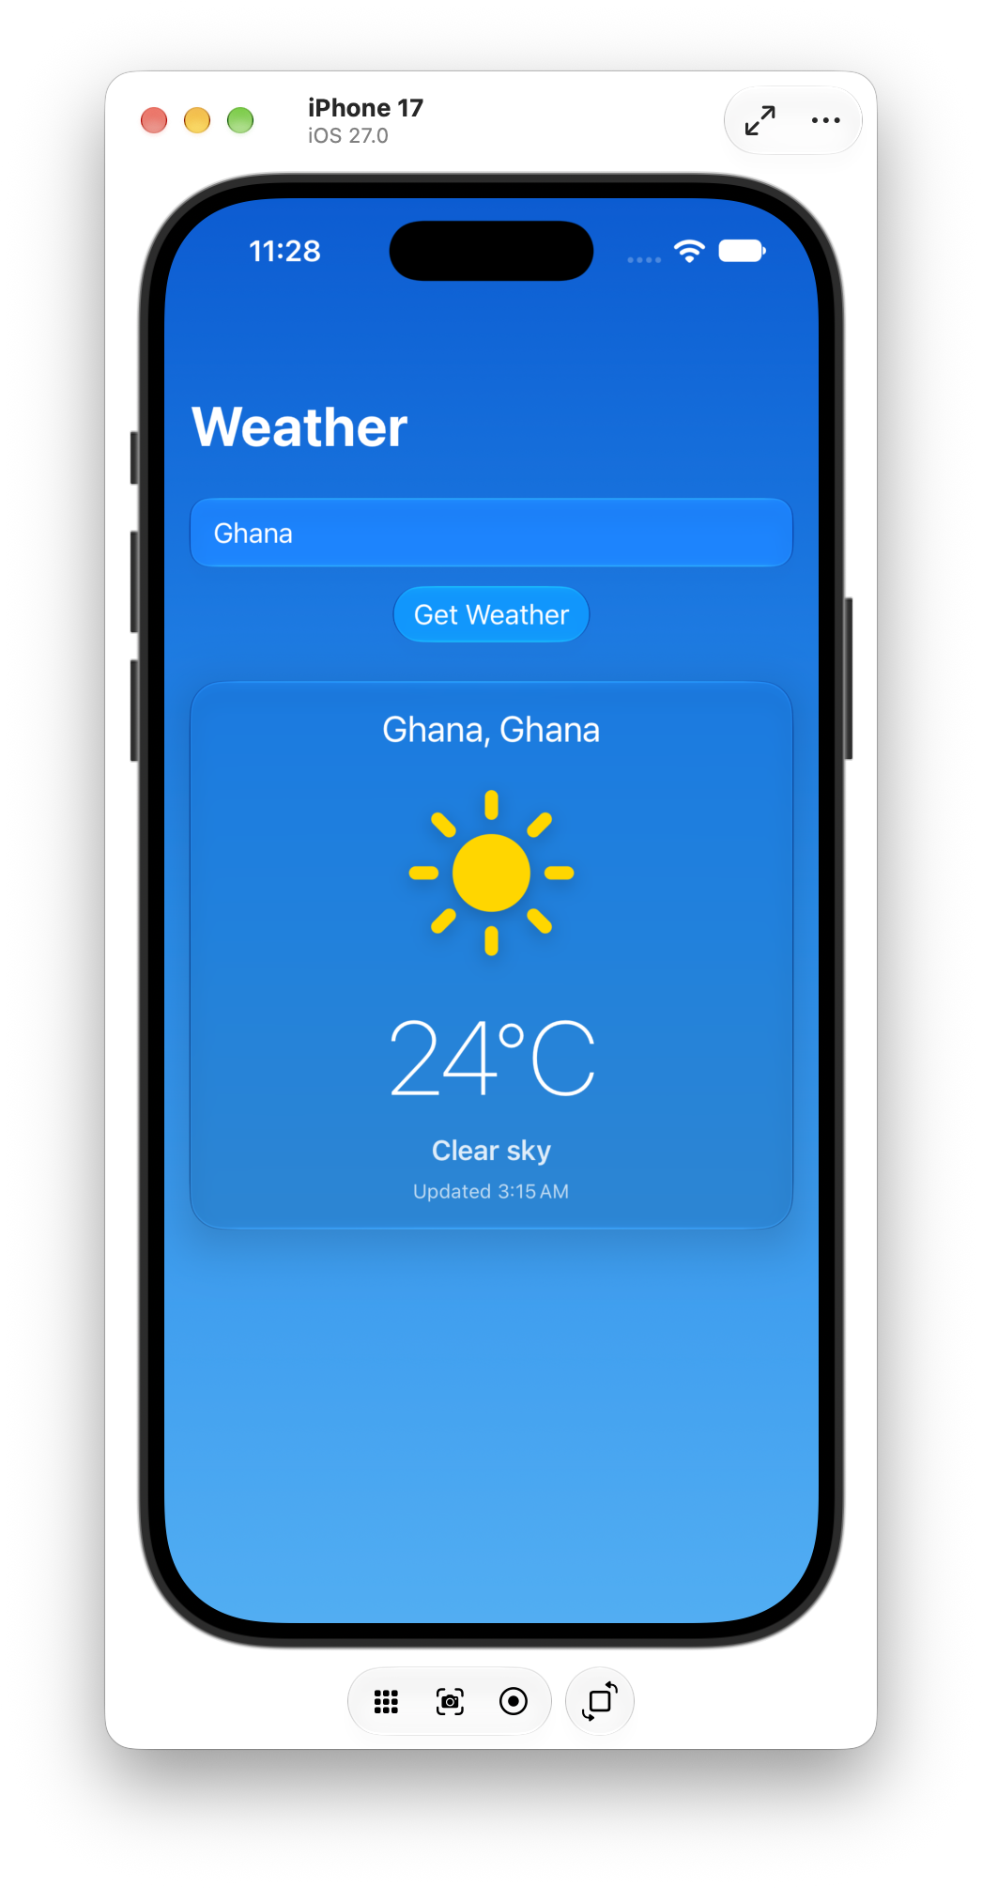
Figure 7. Hampton with an overcast gray-blue theme. | Figure 8. Ghana with a bright clear-sky theme.

Additional test. New York returned Light drizzle and used a different rainy blue theme. This confirmed that different weather codes produced different visual states.

Revision 2 Code Sample
enum WeatherCondition: Equatable, Sendable {
case clear
case partlyCloudy
case cloudy
case fog
case drizzle
case rain
case snow
case thunderstorm
case unknown
}

struct WeatherBackgroundView: View {
let condition: WeatherCondition?
var body: some View {
LinearGradient(
colors: Self.colors(for: condition),
startPoint: .top,
endPoint: .bottom
)
.animation(.easeInOut(duration: 0.8), value: condition)
}
}

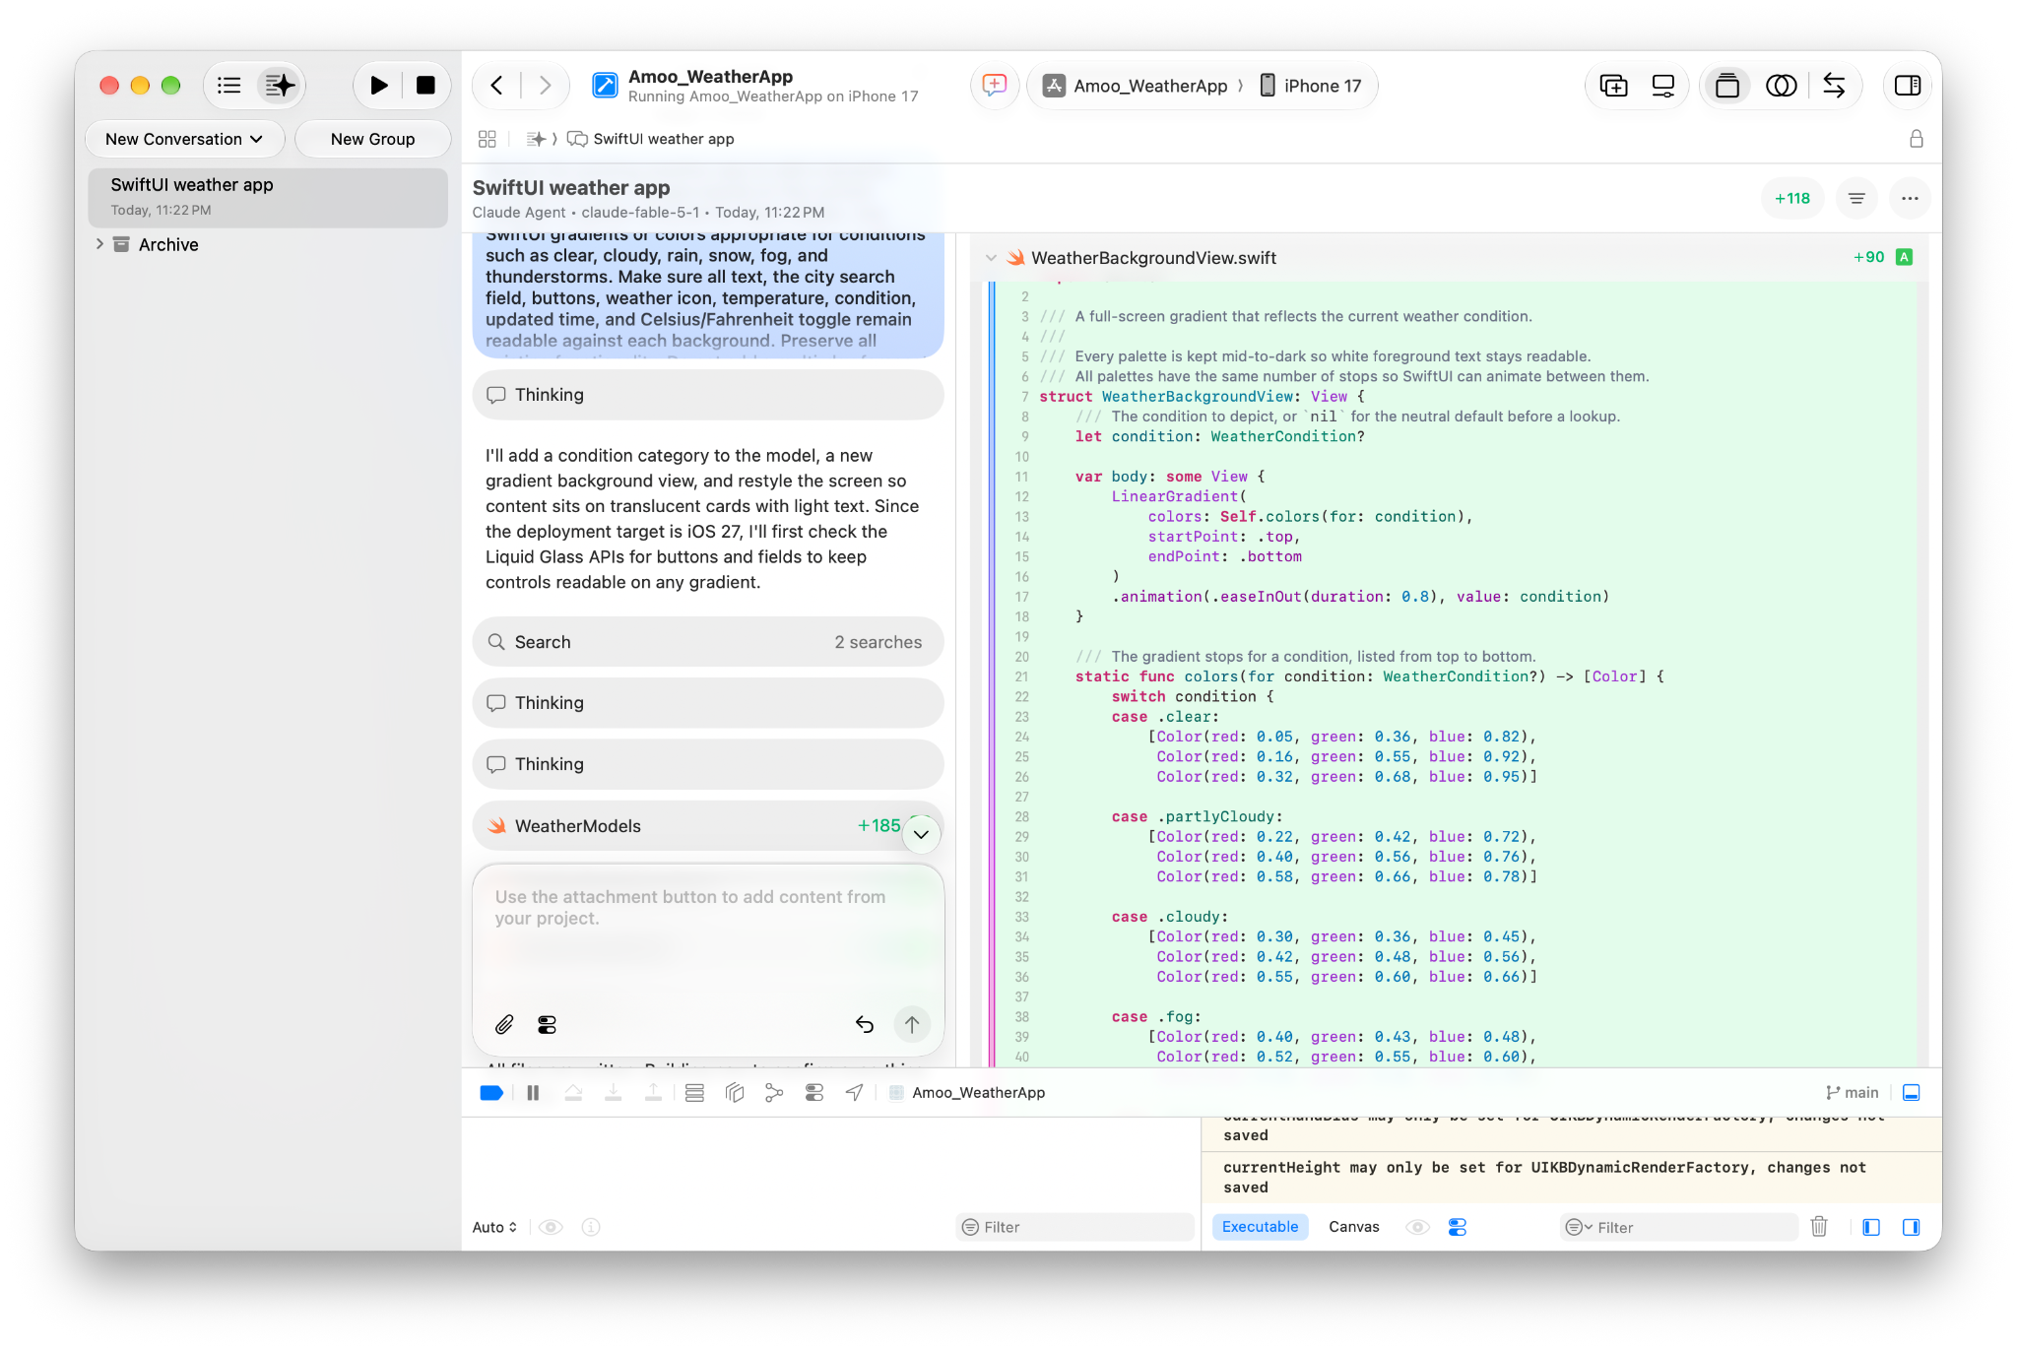
Figure 9. WeatherBackgroundView uses a LinearGradient and condition-specific palettes.
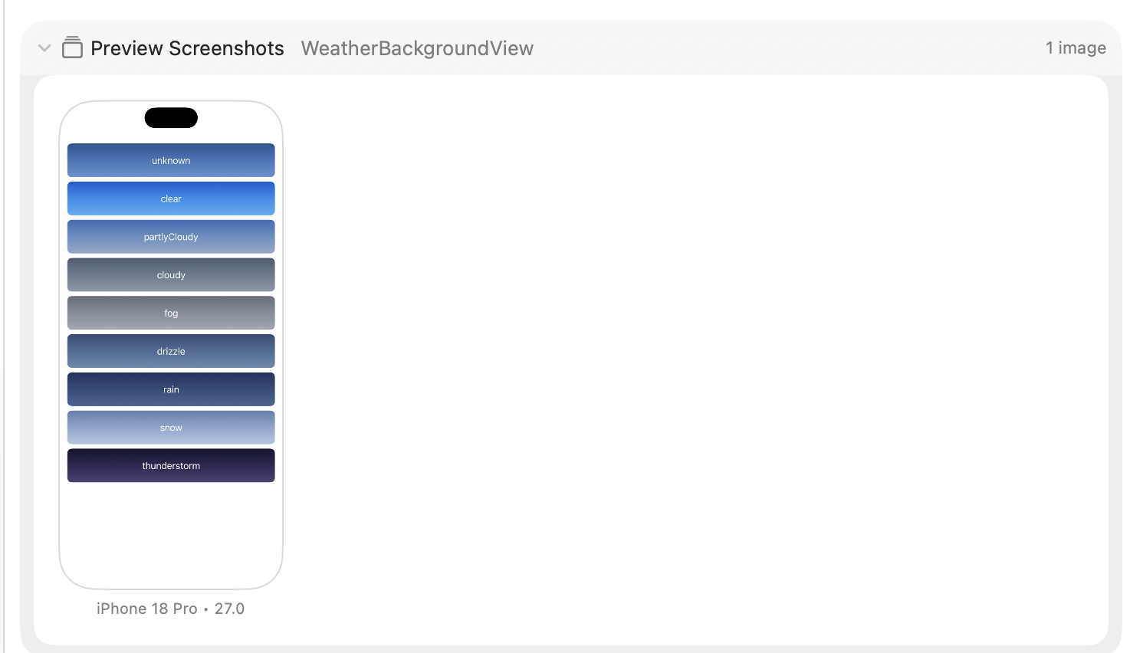
Figure 10. Xcode preview showing the generated background palettes for each condition category.

5. Revision 3 - Multi-Day Forecast

Revised Prompt 3
Revise the existing weather app to add a multi-day forecast beneath the current weather card. Show at least 5 days with the weekday or date, an appropriate SF Symbol weather icon, and the daily high and low temperatures. Retrieve the daily forecast using the existing Open-Meteo API and reuse the existing weather-code mapping where possible. The forecast temperatures must also update when the user switches between Celsius and Fahrenheit. Preserve all current functionality, including city search, current weather, weather icons, the temperature unit toggle, dynamic weather backgrounds, and the existing visual style. Make sure the finished layout remains readable on an iPhone screen and can scroll vertically if needed.

Result. The agent added a seven-day forecast, which exceeded the minimum five-day request. Each row shows the day/date, a weather icon, low temperature, and high temperature. The screen was changed to a ScrollView so the forecast can fit on a phone. The unit toggle also updates the forecast, not just the current temperature.
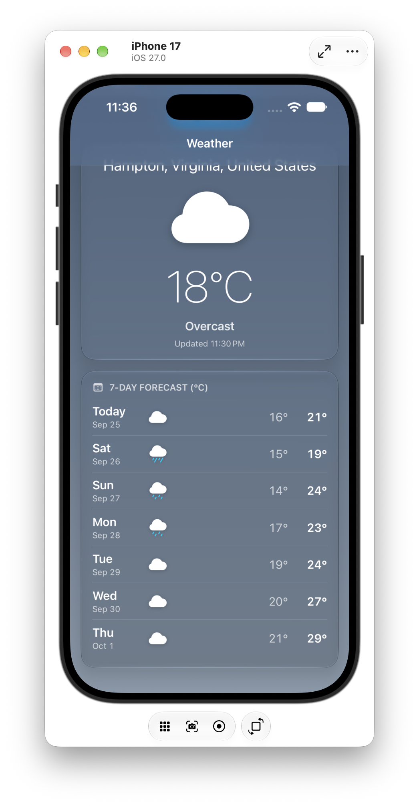 | 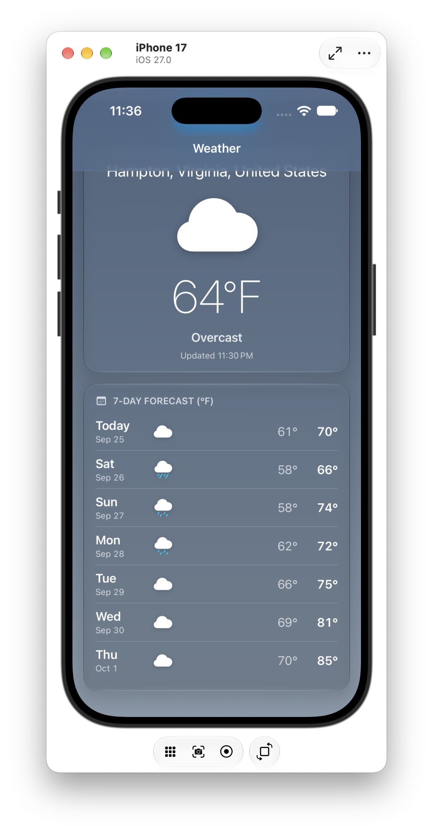
Figure 11. Final seven-day forecast in Celsius. | Figure 12. The same forecast after switching to Fahrenheit.

Revision 3 Code Sample
The service protocol was expanded with a daily forecast function. The existing city lookup and current-weather calls stayed in the same service abstraction.
protocol WeatherService: Sendable {
func geocode(city: String) async throws -> Location
func currentWeather(latitude: Double, longitude: Double) async throws -> CurrentWeather
func dailyForecast(latitude: Double, longitude: Double, days: Int) async throws -> [DailyForecast]
}

The view was also changed from a fixed vertical layout to a scrollable layout so the new rows do not run off the bottom of the screen.
NavigationStack {
ScrollView {
VStack(spacing: 24) {
searchSection
resultSection
}
.padding()
}
.scrollDismissesKeyboard(.interactively)
}

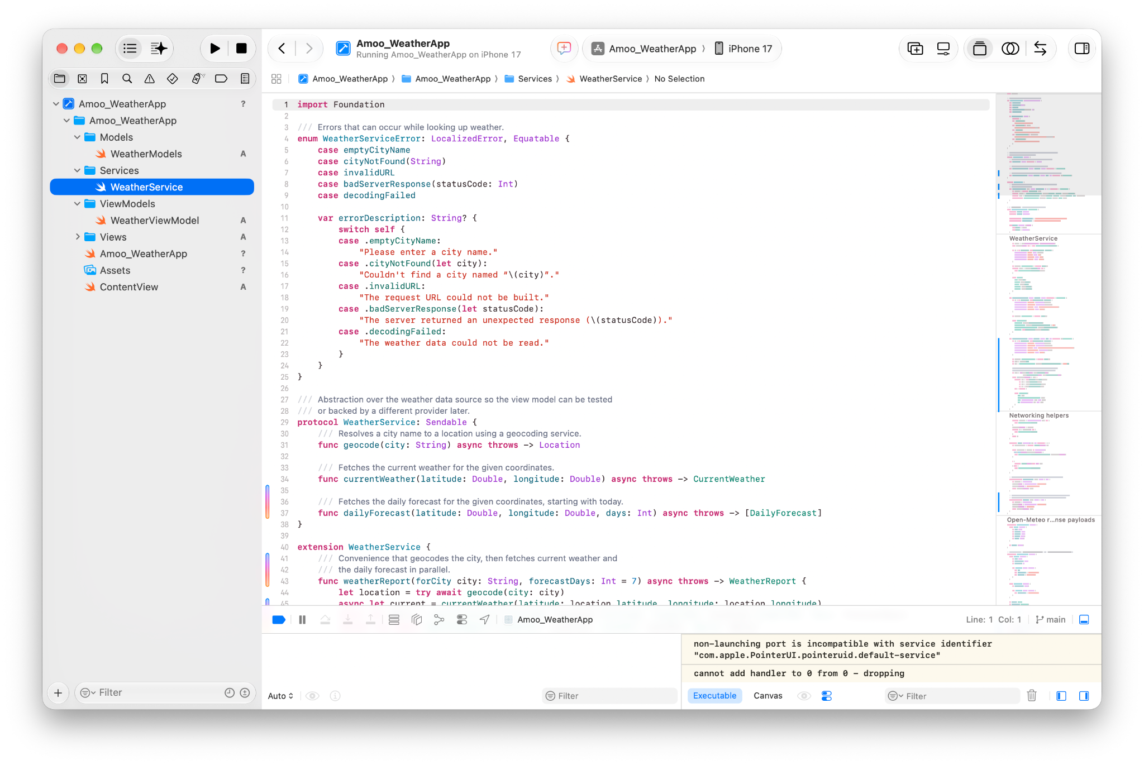
Figure 13. WeatherService after the agent added dailyForecast(...).
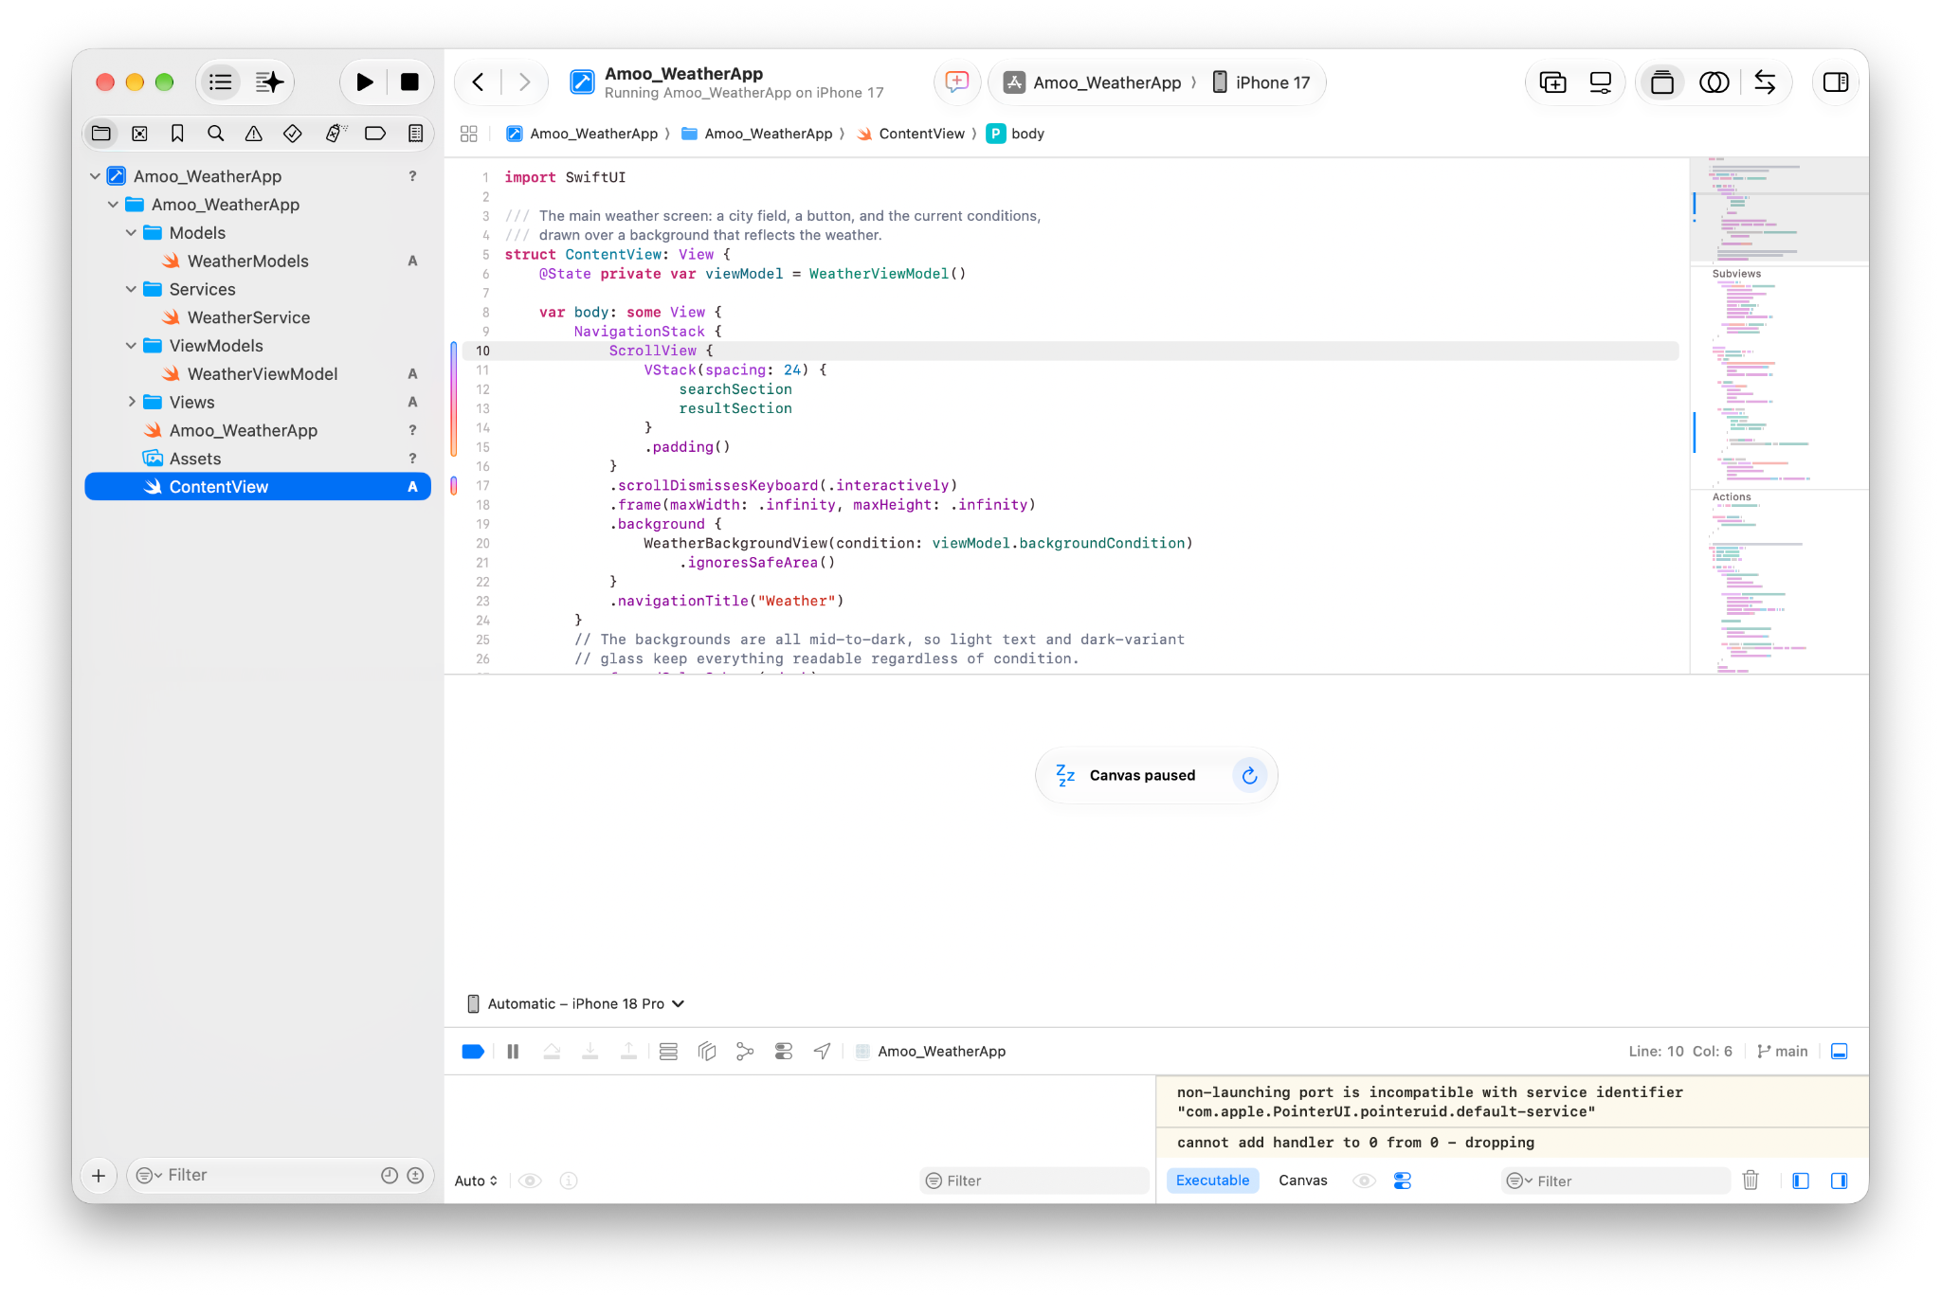
Figure 14. ContentView changed to a ScrollView for the longer forecast layout.

6. What I Observed
The biggest advantage of Agentic Coding was that I could describe a feature at a higher level and then test the code instead of writing every change line by line. The most useful part was revising the same project instead of generating a completely new app each time.
- Specific prompts gave better results. Telling the agent what to preserve prevented it from removing earlier features.
- The agent sometimes added useful behavior that I did not directly request, such as the Celsius/Fahrenheit toggle in Revision 1.
- Testing after every revision mattered. I used Hampton, New York, and Ghana to confirm that icons and backgrounds were really tied to API results.
- The generated architecture made later changes easier. Models held data, the service handled network requests, the view model managed state, and ContentView handled the interface.
- I saw Swift concepts I had not used much before, including async/await API calls, Measurement<UnitTemperature>, code-to-icon mapping, reusable gradient views, and scrollable forecast content.
Final result. The final app met the original requirement for user input and used three documented agentic revisions. It also kept the existing features working while the project grew from a basic weather lookup into a more complete weather interface.

